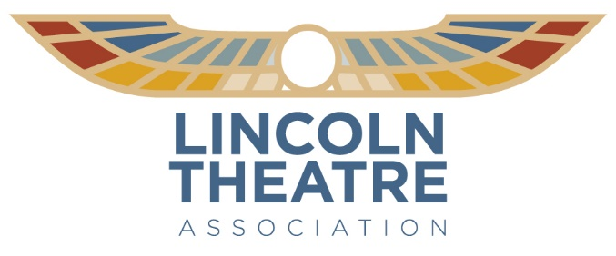

FOR IMMEDIATE RELEASE
July 3, 2025

Lincoln Theatre Walk of Fame to Induct Black Creative Icons Elijah Pierce and Curt Moody

July 26 ceremony will also honor Hardlines Design Company

Presented by State Auto Insurance, the Lincoln Theatre Association will hold its annual Walk of Fame induction ceremony at the Lincoln Theatre (769 E. Long St.) on Saturday, July 26, at 7 pm, to memorialize two pillars of the Black creative community in Columbus, artist Elijah Pierce and architect Curt Moody, as well as vanguard architecture firm Hardlines Design Company, which was responsible for overseeing the restoration of the Lincoln Theatre that began in 2007.

These local trailblazers will be honored during a ceremony that will include a tribute to their lives and work and a performance by a variety of younger artists, including the Ladies of the Lincoln. The day will also include a Neighborhood History Walk throughout the King-Lincoln District from 4 to 6 pm, funded in part by the City of Columbus. Come spend the afternoon on Long Street between Elijah Pierce Avenue and North 17th Street, as the businesses on Long Street will open their doors to all visitors to the KLD.

The event is free and open to the public with pre-registration at www.LincolnTheatreColumbus.com.

“Art and architecture shape the community where they exist. It is the final structure of imagination that impacts universal connoisseurs,” Lincoln Theatre Executive Director Suzan Bradford said.

Elijah Pierce
Elijah Pierce described himself as a "peculiar" child, because he did not want to work on his father's farm like his brothers. Instead, he wandered in the woods surrounding his home and carved animals, figures, and names into tree trunks. He ran away as a teenager and traveled the country by hopping freight trains, eventually settling in Columbus, where he opened a barber shop.

In the late 1920s, Pierce carved a small elephant as a gift for his wife. She liked it so much that he resolved to make an entire zoo and started carving sculptures during every spare moment in the shop. Memories of his religious childhood inspired him to carve images based on scenes from the Bible. He believed God had given him the talent to carve, and that his life's purpose was to make "every sermon I never preached."

Curt Moody
Moody Nolan was founded by architect Curt Moody and engineer Howard E. Nolan in 1983 with the goal of developing a portfolio of private-sector projects, unlike other minority firms. As of June 2024, the firm has 12 office locations and 350 employees. In addition to its headquarters in Columbus, Moody Nolan has established offices in Atlanta, Boston, Chicago, Cincinnati, Cleveland, Dallas, Houston, Philadelphia, Nashville, New York City, and Washington, D.C.

In 2014, the civil engineering practice split off to form Moody Engineering. In 2018, the firm founded the Legacy House Project, which annually gifts a house to a family in need.

In 2020, Curt Moody's son, Jonathan Moody, became the CEO.

Hardlines Design Company
Hardlines Design Company specializes in historic preservation architecture, restoration, adaptive reuse, and the rehabilitation of historic buildings. Since 1990, it has provided extensive historical architecture services to federal agencies, including the Air Force, Navy, Corps of Engineers, National Park Service, Department of Agriculture, and state agencies such as the Ohio Department of Transportation (ODOT) and the Lincoln Theatre.

The Lincoln Theatre project involved documenting, rehabilitating, and expanding a historic theatre listed on the National Register, originally built in the 1920s. This project played a key role in revitalizing a historic downtown neighborhood in Columbus. Originally a fraternity lodge, the theatre served as a significant performance space for African American jazz artists until the 1960s; however, it was left vacant and allowed to deteriorate for nearly four decades.

The initial facility assessment included producing as-built drawings and proposing new uses while maintaining the Theatre's historic integrity.

Starting in 2007, the renovation project encompassed masonry repairs, the reconstruction of historic interior features, new seating arrangements, an expanded stage and orchestra pit, an expanded backstage area, and enhanced patron amenities. The building additions featured new stairs, a theatre balcony, an accessible elevator, dressing rooms, a green room, and a new two-story commemorative exhibition hall/jazz lobby with a concessions area. Sustainable design practices were incorporated in line with former Mayor Michael Coleman’s “Green Initiative.”

The project received significant recognition, including the 2009 Ohio Historic Preservation Office Merit Award and the 2010 Heritage Ohio Award for Best Public Rehabilitation. An all-women team initiated and managed this project. Much of Lincoln Theatre's history was uncovered through the in-depth research conducted by Hardlines, and this information is now utilized for educational, marketing, and patron engagement purposes.

“State Auto shares the Lincoln Theatre’s commitment to this neighborhood and to downtown Columbus. For many years, we’ve been enthusiastic supporters of efforts to revitalize the Lincoln and the surrounding King-Lincoln District,” said Stephanie Meredith, External Relations Director, State Auto Insurance. “We exist to help people embrace today and confidently pursue tomorrow. And we have an unwavering commitment to investing in our communities through financial support, issues-based thought leadership, and employee giving and service.”

www.LincolnTheatreColumbus.com

# # #

Support for the Lincoln Theatre’s 2025-26 season is provided in part by the Greater Columbus Arts Council, The Columbus Foundation’s Katheryn Hudson Reese Fund, Blanca Hambleton Van Buskirk Fund, and the Columbus Town Meeting Association Fund, the Ohio Arts Council, the Nationwide Foundation, State Auto Insurance Companies, Donna and Larry James, Huntington Bank, the AEP Foundation, and Encova Insurance.

About the Lincoln Theatre
First opened in 1928, the Lincoln Theatre is a landmark in African American and jazz history. After undergoing a $13.5 million renovation funded by a partnership of public and private support, the Lincoln reopened in May 2009 as a multi-use, state-of-the-art performing arts and education center serving the diversity of the central Ohio community. The Lincoln is a bustling hub of activity 365 days a year hosting performances, rehearsals, and classes in the performing arts, as well as a wide variety of community events such as film festivals, meetings, and receptions.

Contact: Jim Fischer
(614) 719-6624
jfischer@capa.com

